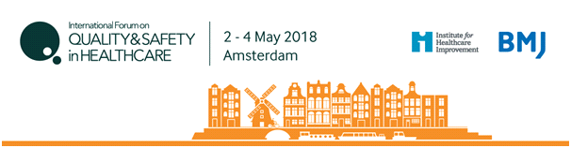
International Improvement Science and Research Symposium
Wednesday 2 May 2018
SPEAKER PROPOSAL Abstract Template

Abstract submissions are now being accepted for presentations at the International Improvement Science and Research Symposium 2018 in Amsterdam.

Peer-reviewers of the speaker proposal are looking for exemplary research of an international standard which represents the cutting edge of improvement science research. Speaker proposals should have a wide ranging appeal to all audience members of the International Improvement Science and Research Symposium. The selection process is highly rigorous and only a very limited number of high quality abstracts will be accepted for speakers.

Speaker proposals should demonstrate one or a combination of the following:
- Significant methodological or theoretical advancement,
- Research with significant impact for patients, populations or care services,
- Advancements in collaborative working between researchers, practitioners and patients,
- Demonstration of novel or significant contributions from new perspectives including academic disciplines, industry or patient or community perspectives
- Has significant implications for policy, practice or research.

Your abstract must be submitted in the following format to be considered for the International Improvement Science and Research Symposium:

- Maximum of 1500 words (not including template headings)
- Maximum of two figures or tables if required
- Provide the following elements in order
  - Title
  - Authors
  - Institution
  - Introduction
  - Methods
  - Results
  - Discussion
  - References
  - Declaration of competing interests

- Ensure that you address the following in your abstract submission:
  - Describe the background to the improvement science research conducted. What is already known on this subject and what gaps in knowledge exist?
  - State clearly the research question the study was designed to answer and what is novel about the research conducted.
  - Describe the methods used to answer your research question, reflecting where appropriate on the relevant academic disciplines that informed your study design and the extent to which collaboration took place between different academic disciplines and with healthcare practitioners, policy makers and patients or community members.
  - Describe the results of your study and reflect on the contribution they make to advancing knowledge and practice of improvement science.
  - Describe the wider implications and potential of this research to influence how we improve heath and health care and its applicability to other areas and settings

SPEAKER PROPOSAL FOR THE INTERNATIONAL IMPROVEMENT SCIENCE AND RESEARCH SYMPOSIUM
Please complete your submission below (maximum 1500 words):

1) Title:

2) Authors:

3) Institution:

4) Introduction:

5) Methods:

6) Results:

7) Discussion:

8) References (up to 10)

9) Declaration of competing interests

