International Forum New Delhi, Booking Guidelines

How to register

Click here to register

If you wish to book between 1-49 delegates, please download the group import template by clicking HERE. Once completed, please send the template to ifqsh20@iceindia.in. Our team will send you the invoice for processing. Please note: All group members should be from the same organisation and an invoice will be raised in the name of Group Leader (mentioned in the template).

STEP 1: You will be asked to select your booking type.
- If you are completing an individual registration, select Individual booking
- If you will be attending as part of the group, please download the group import template by clicking HERE. Once completed, please send the template to ifqsh20@iceindia.in.

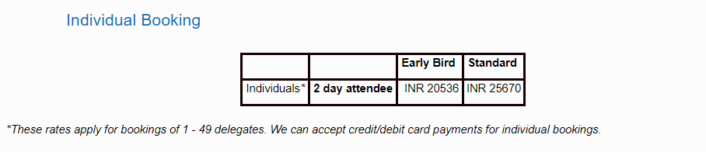

STEP 2: Enter your contact details
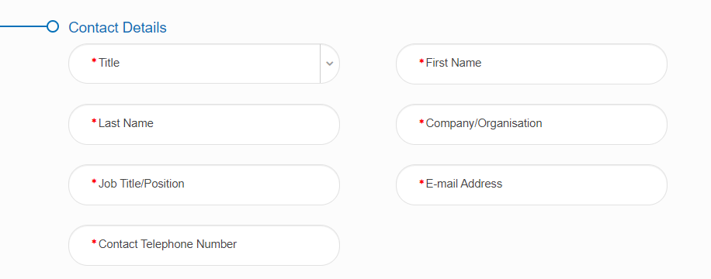

STEP 3:You will be taken to the Booking Summary page. You will need to accept the event terms and conditions.

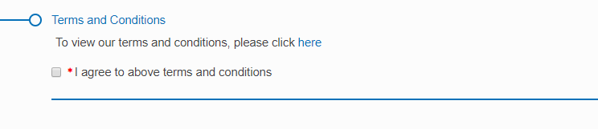

STEP 4: Once you have completed registration, you will need to select your payment method.
The available method is credit/debit card. The option for invoice payment is applicable for groups of 5 or more delegates only. Then click Pay Now / Complete Registration and you will either be taken to the payment page or to a page confirming your booking.

If you pay via invoice (available to groups of 5+ delegates only), the invoice will be issued in 5-7 working days. If you anticipate any major changes to the group, please contact ifqsh20@iceindia.in and we can wait until your booking is finalised to raise the invoice. The following things can affect your invoice:

STEP 5: Once you have registered and made payment, within 72 hours you will receive an invitation to complete your registration from events@bmj.com
To finalise your booking, you will need to check your details and select your sessions on our booking platform. Please complete the following steps:
1. Access your booking from the link in the email
2. Check your personal details and update if necessary
3. Select your sessions
4. Click 'complete registration'.
Your booking will not be finalised until the above steps have been processed and you have received a booking confirmation email.

If you do not find the answer to your question here, please email our team at events@bmj.com or call +44(0) 207 111 1105. Our office hours are Monday - Friday, 9am - 5pm (GMT).

