International Forum Melbourne, Session Selection Guidelines
Access an existing booking by clicking here

Click here to view the full programme

STEP 1: You will need to enter the same email address and password that you registered with to access your record before clicking Proceed.
If you are part of a group booking, you will not be able to enter the group registration with your own email address, unless you are the registration contact. Please request the unique amendment link from the registration contact (they will have received this in the booking confirmation email).
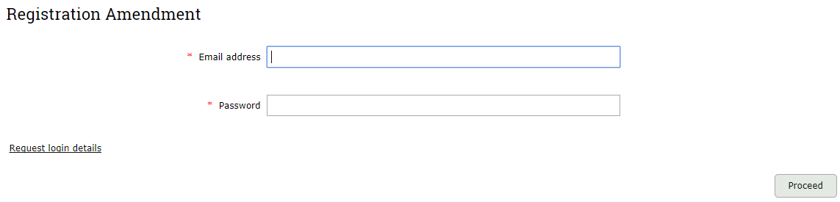
STEP 2: You will be taken to Booking Details page.
Here you can click Edit next to your name.
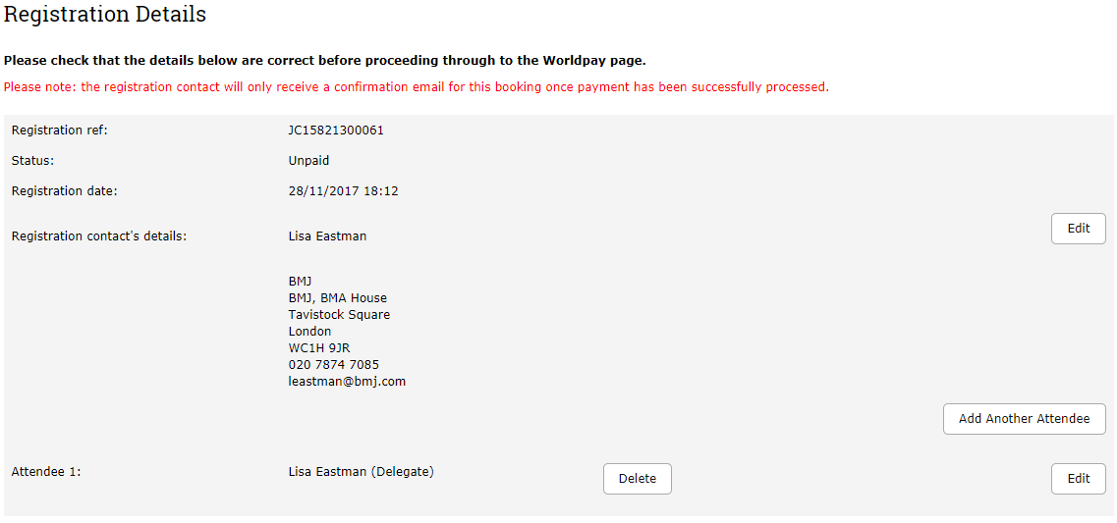
↑

STEP 3: Check your details are correct on the Delegate Details page.
Amend if necessary. Click Proceed.

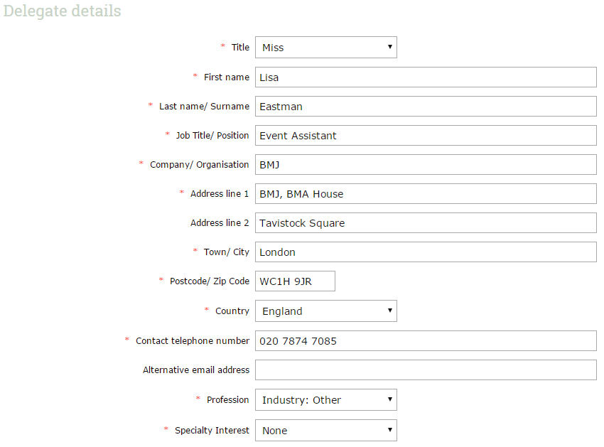
STEP 4: Unless you are planning to amend the days in which you are attending, please click Proceed to be taken to the Session Selection page.
Note - selecting additional days will affect the price of your registration.
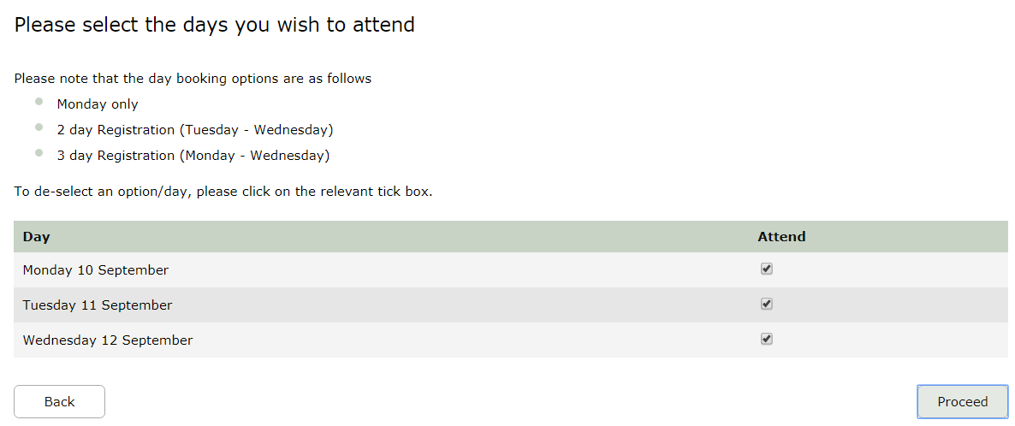

STEP 5: Select your sessions
You have now reached the Session Selection page. A full list of session titles for each day will appear on your screen. You can either click on each session to find out more information or view the full programme here. Once you have made your decision, please tick the sessions you wish to attend. Once chosen, click Next.

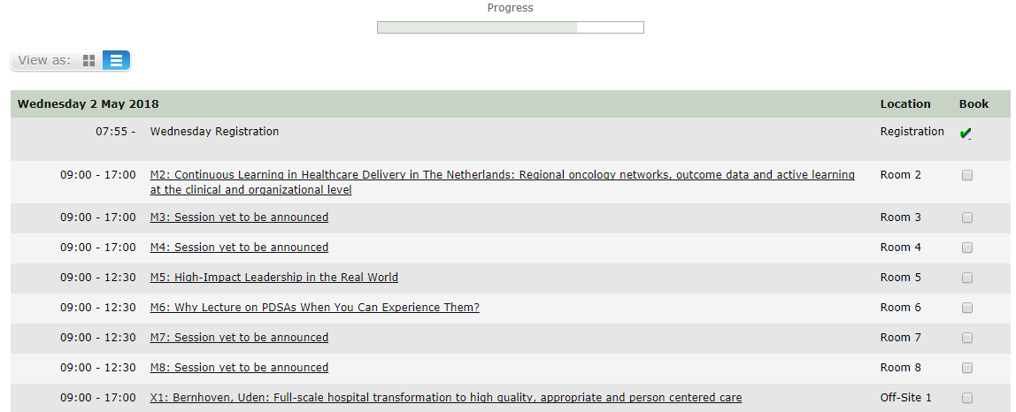

STEP 6: To confirm your session bookings, please click Complete Registration on the Booking Details page
Failure to do so will result in your changes not being saved and your record not being updated.

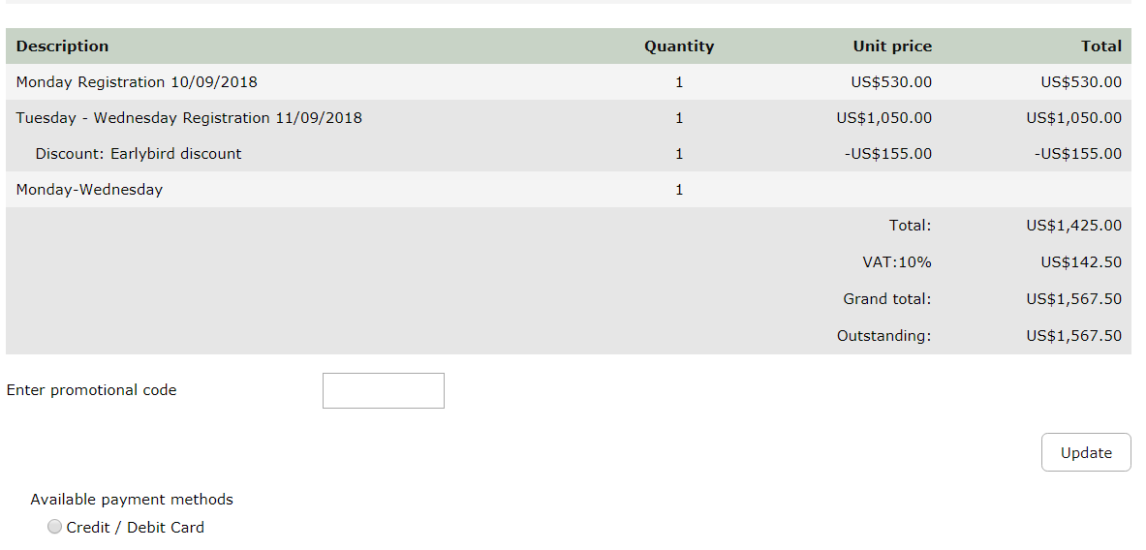

** Any changes made to the registration, if correctly saved, should trigger an Amended Registration email, which would be sent to the registration contact **

