International Forum Melbourne, Booking Guidelines

How to register

Click here to register

If you are booking in a group, ideally it is best to have a central person, the ‘registration contact’, manage your group booking. This person’s email address will be the central log-in for the group.

STEP 1: You will be asked to select your booking type.
- If you are completing an individual registration, select I am registering for myself.
- If you will not be attending, please select I am registering on behalf of other people.
- If you will be attending as part of the group, please select I am registering for myself and other people.

STEP 2: Enter your (the registration contact’s) email address.
Note - If you have attended previously, the system will ask for your password. If you do not know your password you can request for a password reset link to be emailed to you.

STEP 3: Enter your (the registration contact’s) personal details.

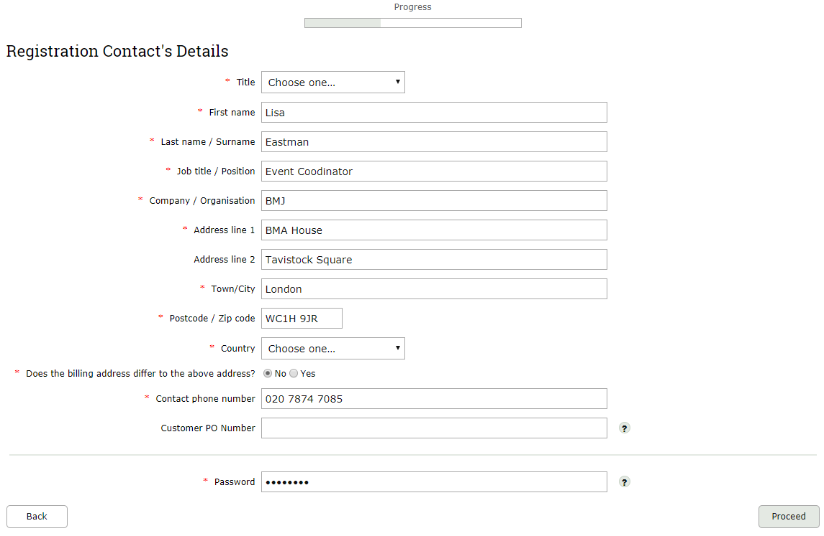

** If you chose I am registering on behalf of other people, you will be prompted here to enter your first attendee’s email address **

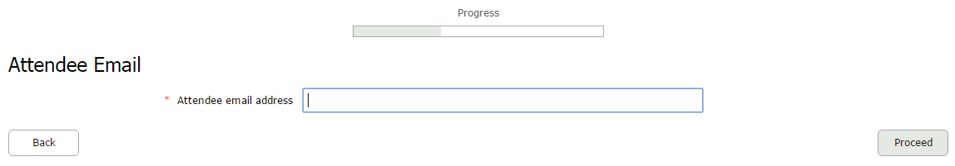

STEP 4: Select your / your first delegate’s attendee category.
Note - the group discount applies only to the Delegate attendee type. If you add any other attendee types (i.e. Speaker or Student), they will not contribute to the number for the group discount.

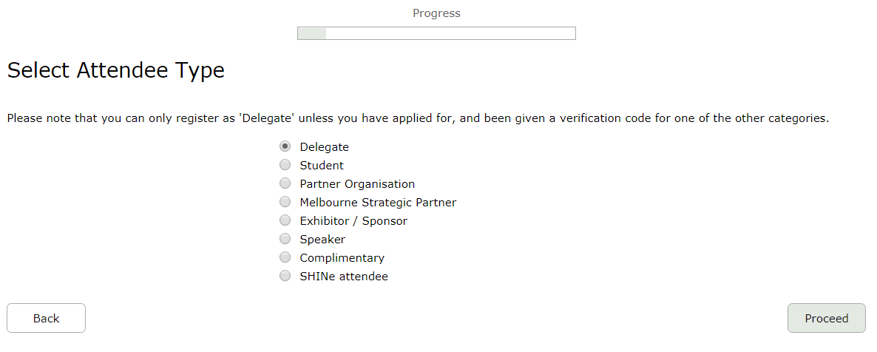

STEP 5: Complete the Delegate Details page.

STEP 6: Select which days you / your first delegate would like to attend.
The booking options are:
- Monday only
- Monday - Wednesday
- Tuesday - Wednesday
Note - You can mix day selections within your group.

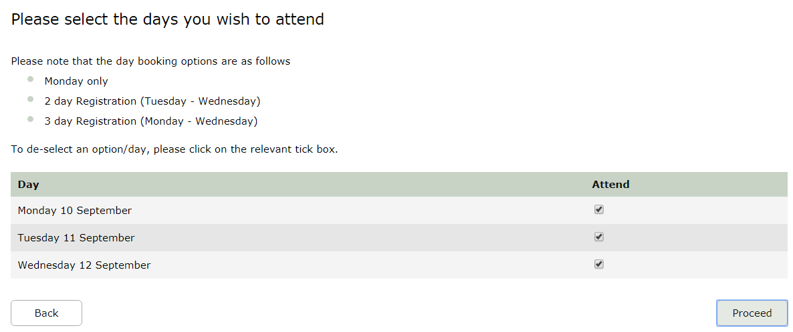

STEP 7: Select which sessions you / your first delegate wish to attend.
Note - for group bookings, if you do not know each person’s session choices, you can give them your (the registration contact’s) email address and password which will allow them to log into the booking at a later date in order to select their sessions.

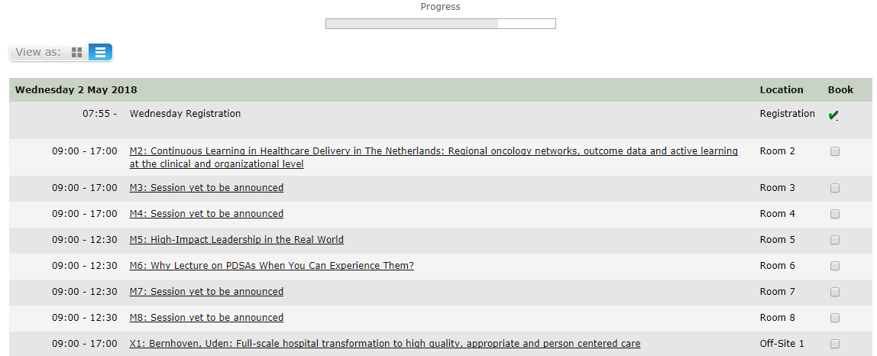

STEP 8: You will be taken to the Booking Summary page.
If you are booking additional delegates in a group, here you can click Add Another Attendee and continue with the booking until you have registered everyone in the group.

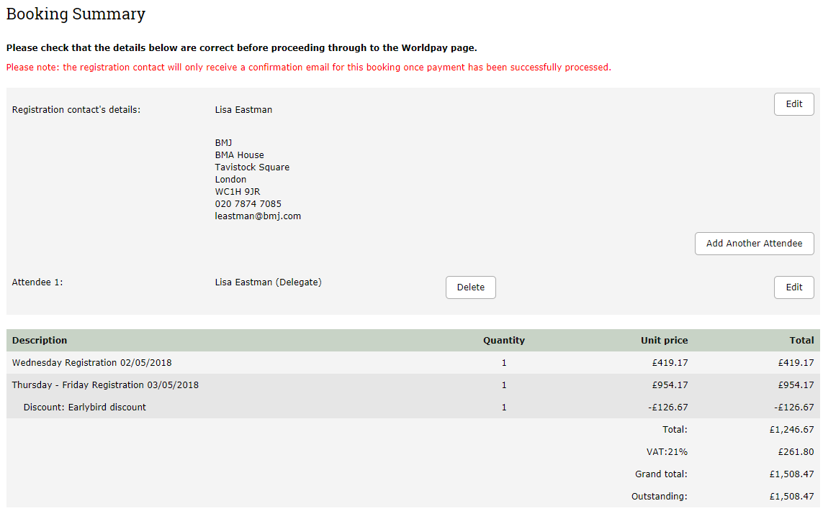

STEP 9: Once you have completed registration, you will need to select your payment method.
The available method is credit/debit card. The option for invoice payment is applicable for groups of 5 or more delegates only. Then click Pay Now / Complete Registration and you will either be taken to the Worldpay payment page or to a page confirming your booking.
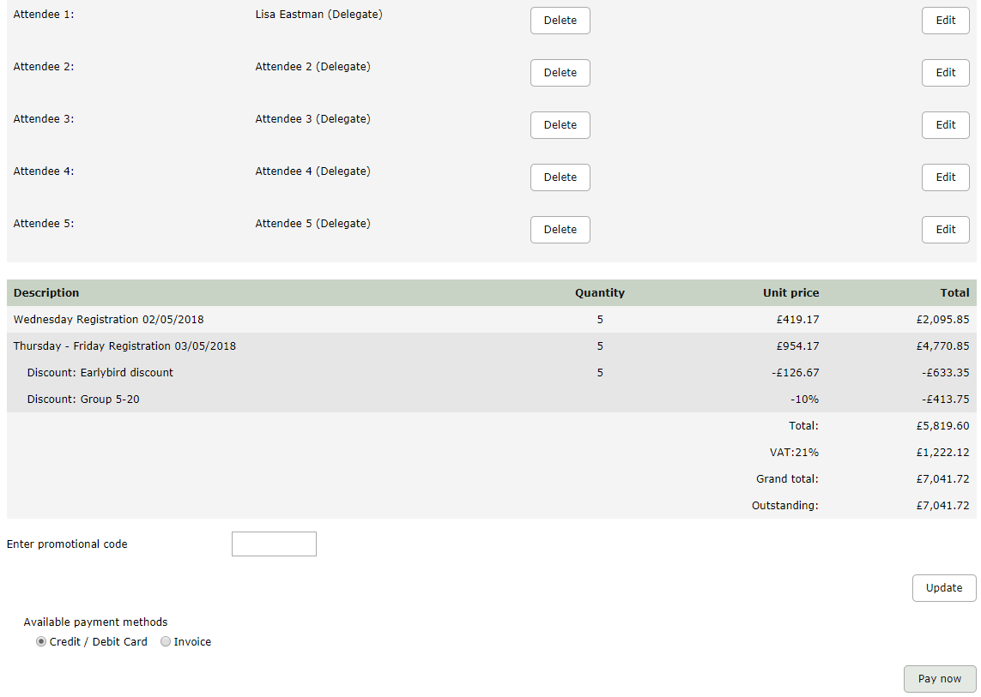
Please note:
- The booking confirmation email will be sent to the registration contact only.
- For amendments made to the booking, you must click the button on the Booking Summary page in order for them to be saved.

If you pay via Worldpay, you will receive a separate email with confirmation of your transaction.

If you pay via invoice (available to groups of 5+ delegates only), the invoice will be issued in 5-7 working days. If you anticipate any major changes to the group, please contact events@bmj.com and we can wait until your booking is finalised to raise the invoice. The following things can affect your invoice:
- Adding additional delegates to your booking
- Removing delegates from your booking
- Changing any information of where/ who the invoice should be addressed to
- Adding a purchase order number or reference number

