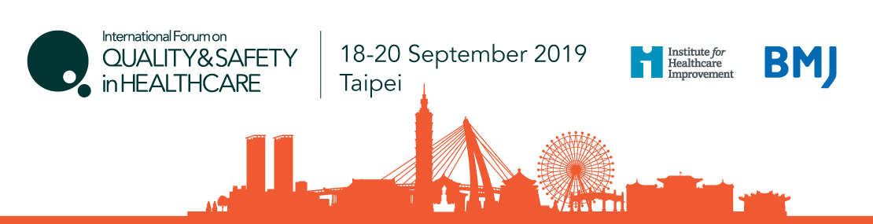
International Forum on Quality and Safety in Healthcare
Abstract Proposal for Poster Display

- Abstracts must be submitted in English
- Abstracts must not exceed 700 words (not including the template text)
- All information (including tables) must be included in a single document
- Please ensure you save your document with a title that is only letters and numbers. Please do not include any symbols as you may have problems uploading this.
- By uploading your abstract you hereby agree to grant BMJ and IHI a non-exclusive licence on these terms.

1) Please declare any conflicts of interest below – for example: who has funded your research; any other competing interest which could be connected with your work (for example, advisory roles or business interests)

2) Context:
- Describe the department or community where the work was done
- Describe the team involved and the client/patient group that is the focus of your work

3) Problem:
- Outline briefly the specific problem or system dysfunction that you aim to improve and how it was affecting client/patient care?

4) Assessment of problem and analysis of its causes:
- Describe how you assessed the cause and extent of the problem
- How did you involve the relevant staff group(s) at this stage
- How did you disseminate the analysis of the problem(s) to the staff and to the patient groups involved

5) Intervention:
- Describe the changes to practice needed to make improvements in care
- Then describe your proposed change(s) to practice in sufficient detail so that others could reproduce it

6) Strategy for change:
- Describe the process and timelines for implementing the change
- Outline how you involve staff groups to disseminate the change
- Outline the opportunities for feedback from the staff and patient groups involved

7) Measurement of improvement:
- Describe your approach to measuring the effect of the change
- Include the analytical methods used and the results obtained
- Please state clearly if you do not have final results available, but indicate any preliminary and anticipated final results

8) Effects of changes:
- What was the impact of your changes?
- Describe how far this went to resolve the problems that triggered your work
- Describe the benefits, actual or anticipated, to client/patient care
- Outline the problems encountered during the process of change
- If you are presenting longer-term follow-up results, indicate the factors that have led to sustained or spread of improvement over time

9) Lessons learnt:
- Outline the lessons about the implementation of change that you have learnt from this work?
- What would you differently if you were starting again?
- If your work is still in progress, indicate any anticipated challenges or obstacles for your project

10) Messages for others:
- Describe the main message from your experience described here that you would like to give to others, or to receive support from others for?
- Describe the impact of your changes for clients/patients and for the health care system as a whole

11) Please describe how you have involved patients, carers or family members in the project:
- Outline any involvement from the start of the projected through to the end

12) Ethics Approval: If ethics approval was required for the work, please state if this has been obtained

